**Project Report Template**

1. INTRODUCTION

1.1 overview

Fresh Bites Catering is a company specializing in providing catering services for a wide range of events and occasions. Their services typically include menu customization, food preparation, delivery, and setup. They offer diverse cuisine options, including appetizers, main courses, and desserts, tailored to the client's preferences. Fresh Bites is known for its commitment to using fresh and high-quality ingredients, ensuring a delightful dining experience for their customers. To provide a more detailed overview, please specify if you have any specific questions or aspects you'd like to explore further.

1.2 purpose

1. **Quality Food**: To serve fresh, flavorful, and well-prepared food to meet the culinary desires of their customers.

2. **Event Catering**: To cater to various events, ensuring that the food and service are tailored to the specific needs of each occasion.

3. **Customer Satisfaction**: To prioritize customer satisfaction by providing excellent food and service, making events memorable.

4. **Diverse Menu**: To offer a diverse menu that accommodates various tastes and dietary preferences.

5. **Professional Service**: To provide professional catering services, including setup, serving, and cleanup.

6. **Customization**: To work closely with clients to customize menus and services according to their preferences and requirements.

2. Problem Definition & Design Thinking

2.1 empathy map

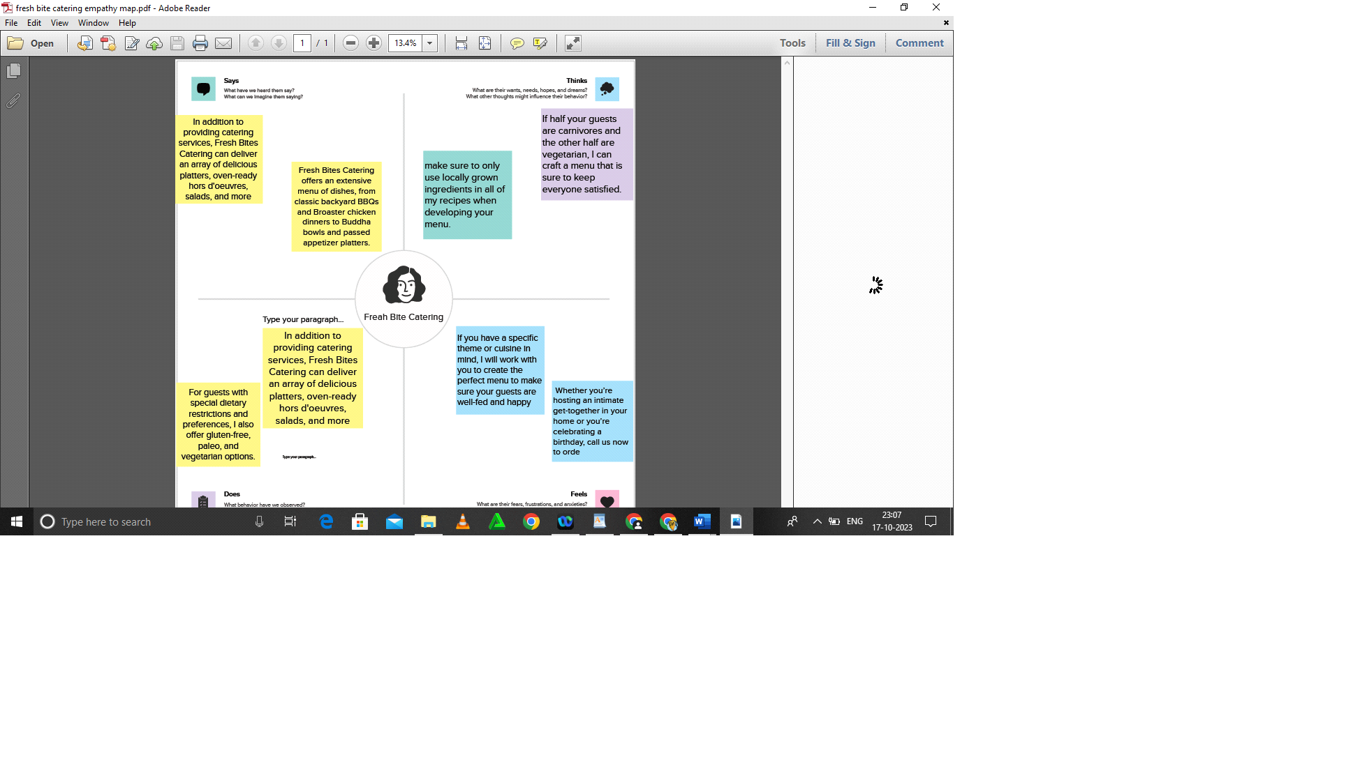

2.2 Ideation & brainstorming map

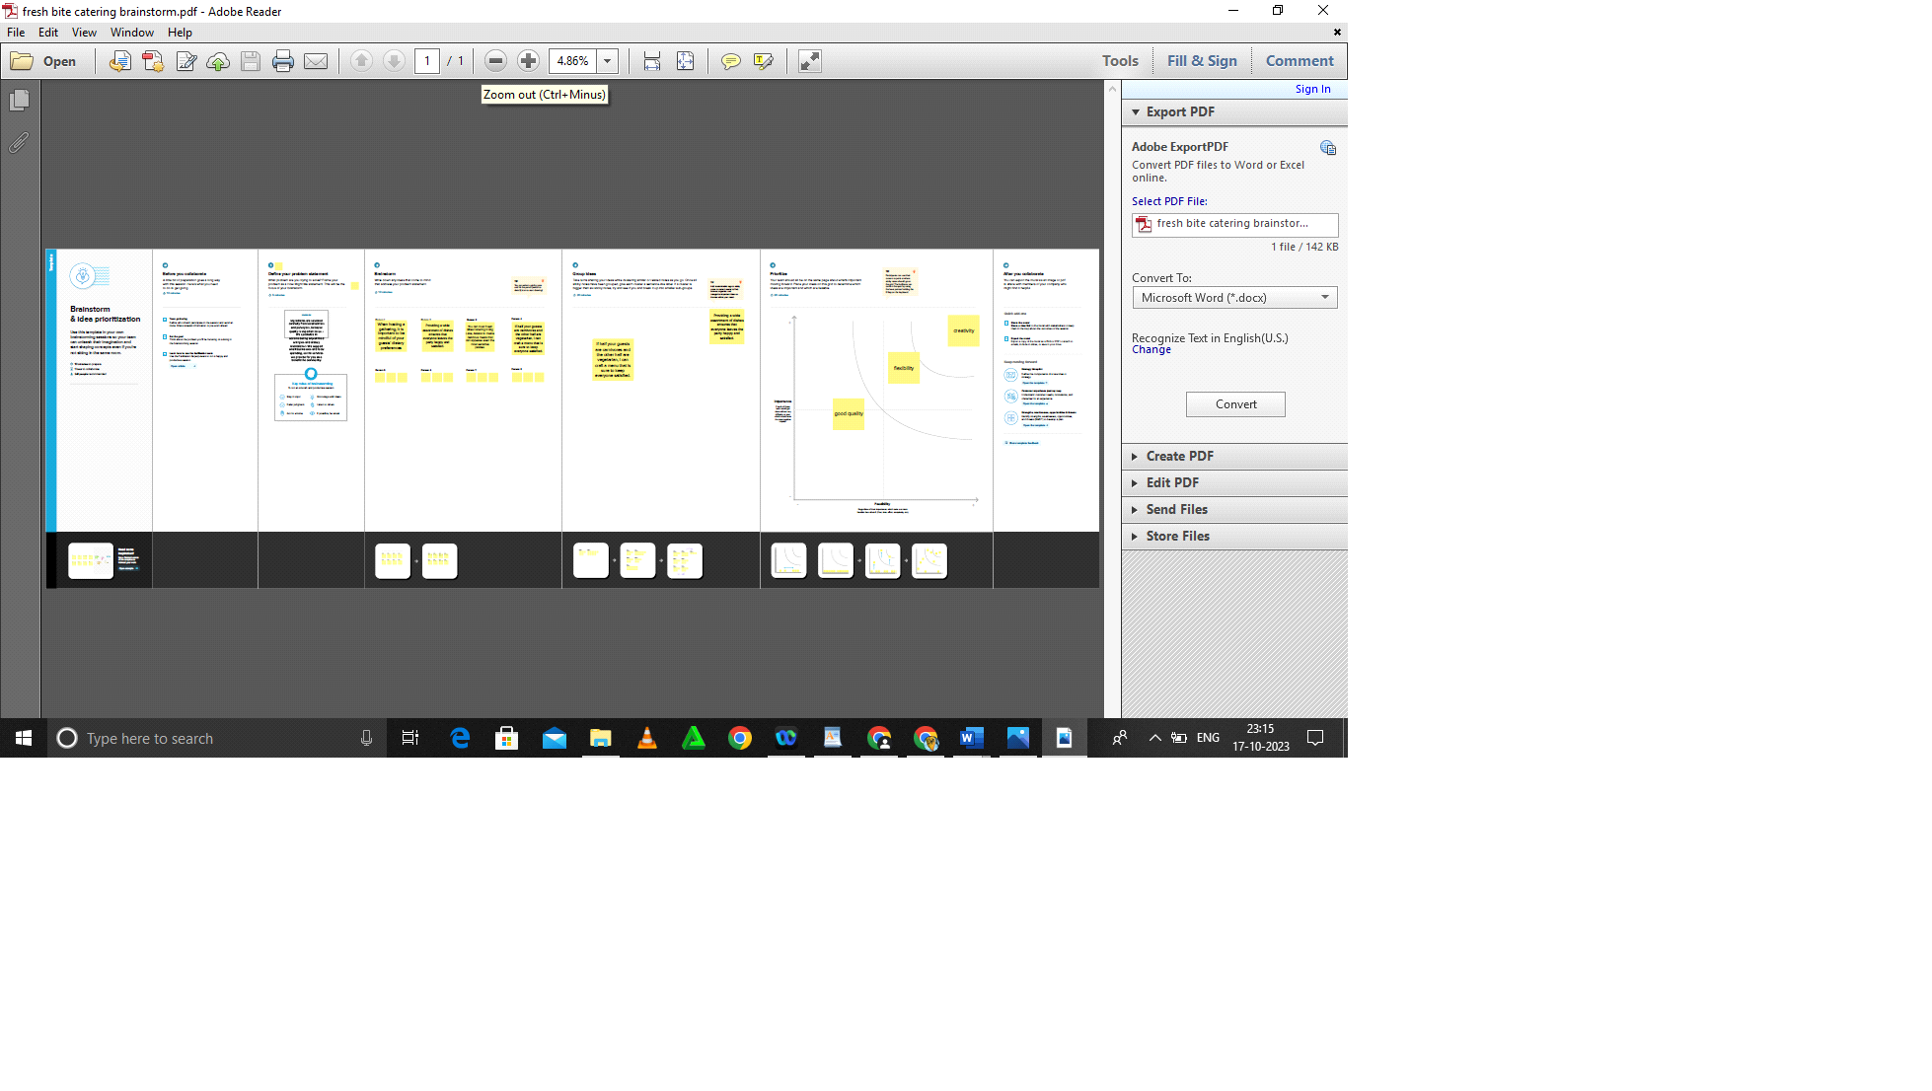

**3. RESULT**

Catering is the process or business of preparing food and providing food services for clients at remote locations, such as hotels, restaurants, offices, concerts, and events. Companies that offer food, drinks, and other services to various customers, typically for special occasions, make up the catering sector.

PROFIT & LOSS

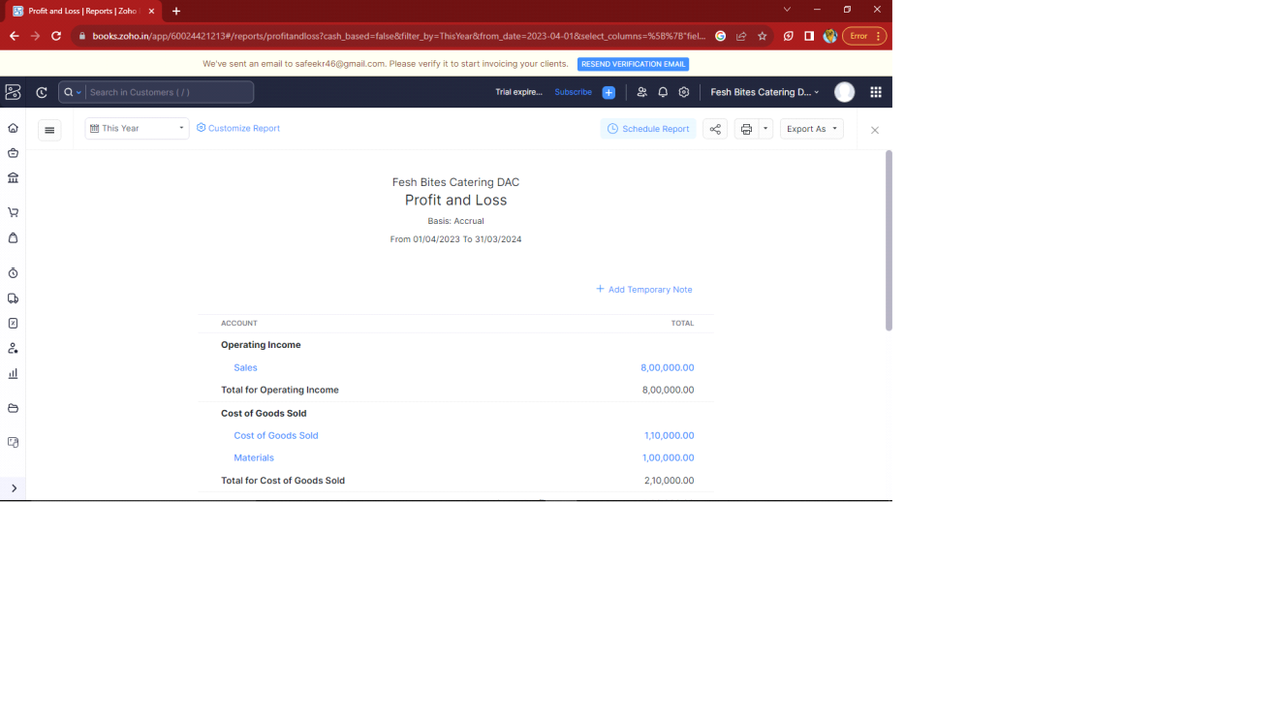

BALANCE SHEET

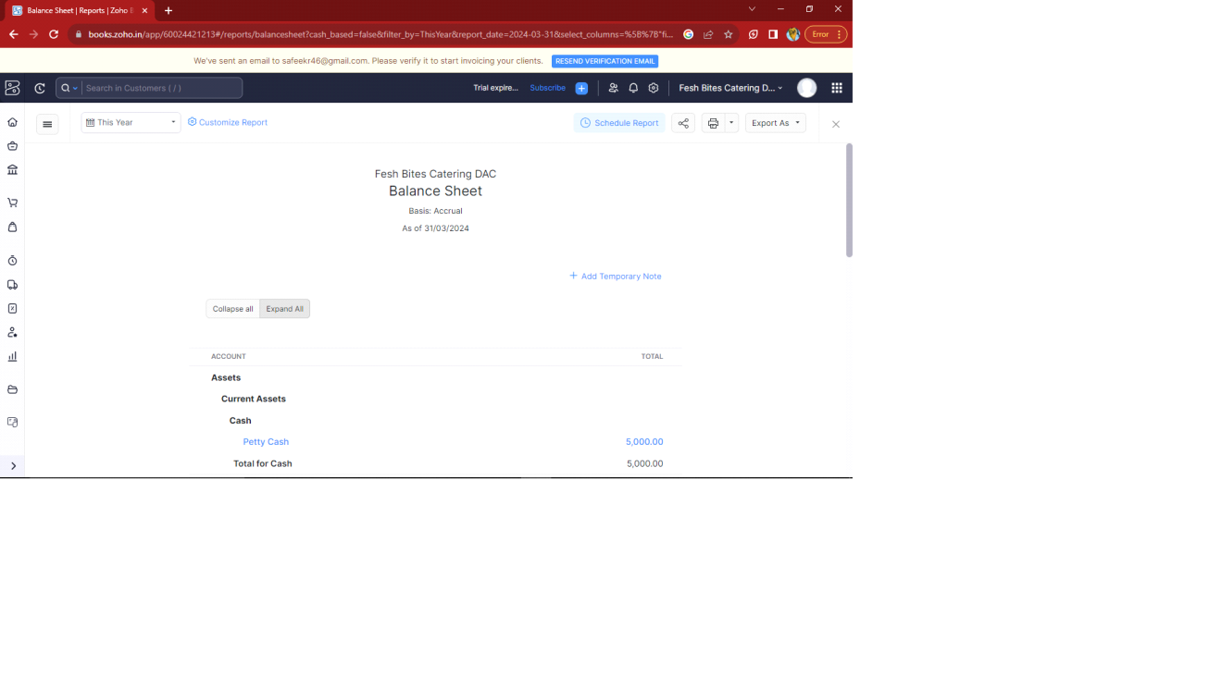

GST Reports

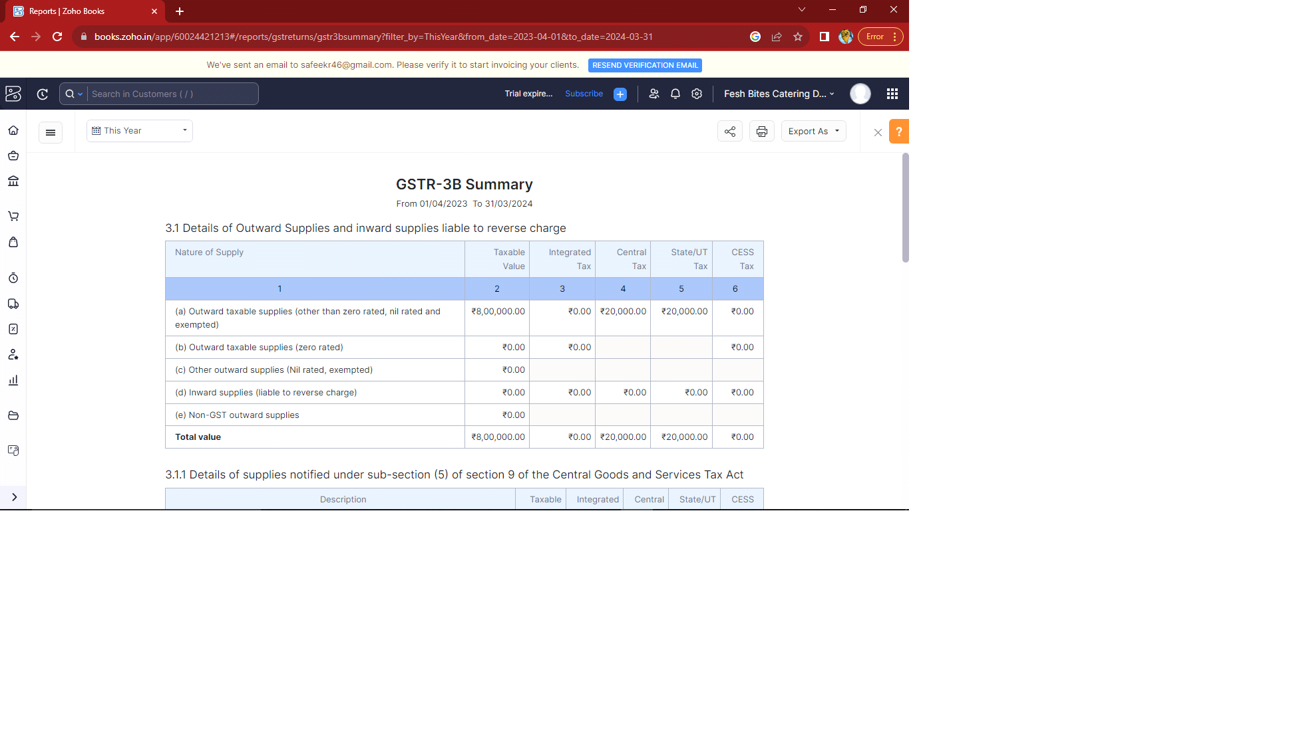

TAX Return

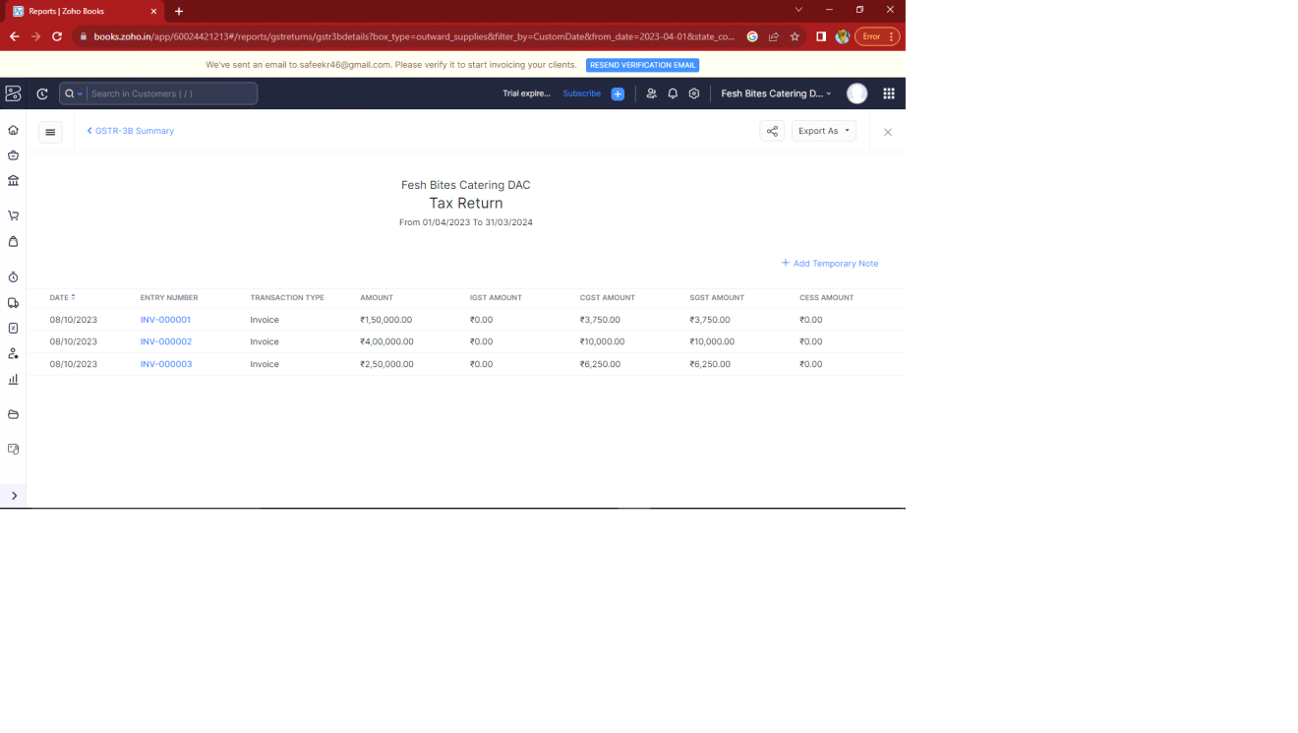

Journal Report

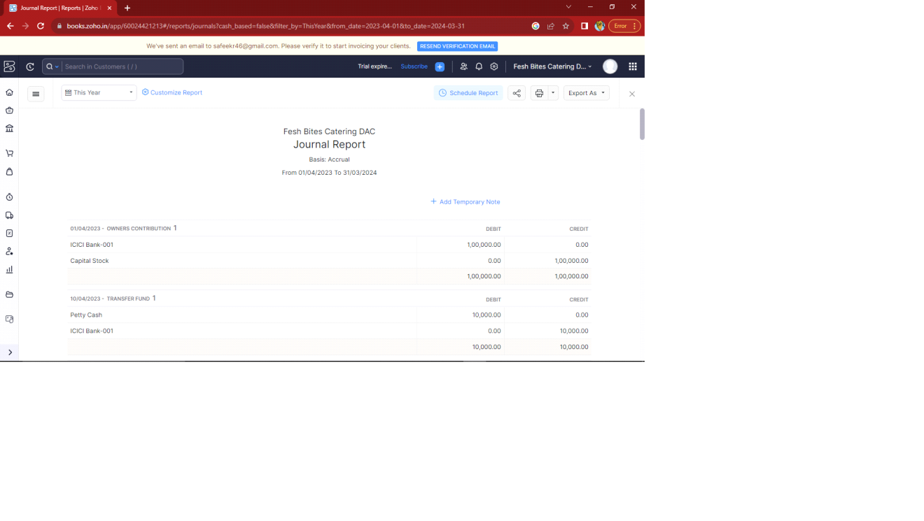

4. ADVANTAGES & DISADVANTAGES

Advantages :

1. **Quality Ingredients**: Fresh Bites focuses on using high-quality, fresh ingredients, ensuring that the food is flavorful and appealing.

2. **Variety**: They often offer a diverse menu with a wide range of options to suit different tastes and dietary preferences.

3. **Convenience**: Catering can save you time and effort in planning and preparing meals for an event or gathering.

4. **Professional Service**: Experienced catering teams can provide professional service, making your event run smoothly.

5. **Customization**: Many catering services, including Fresh Bites, allow you to customize the menu to meet your specific requirements.

Disadvantages :

1. **Cost**: Catering services, including Fresh Bites, can be more expensive than preparing food yourself, especially for smaller events.

2. **Limited Control**: You may have limited control over the preparation and presentation of the food compared to cooking it yourself.

3. **Menu Restrictions**: Some catering companies have set menus, which may not fully align with your specific preferences or dietary requirements.

4. **Scheduling**: Catering services may have limited availability, and you'll need to book in advance to secure their services.

5. APPLICATIONS

Fresh Bites Catering can offer several advantages, depending on your specific needs and preferences. Some potential benefits of Fresh Bites Catering might include:

1.corporate events

2. Weddings

3. Private parties

4. Social gatherings

5. Health care institutions

6. Sports events

7. Religious celebrations

8. Cultural festivals

6. CONCLUSION

In conclusion, Fresh Bites Catering is a service that provides a refreshing and convenient solution for individuals and organizations looking to meet their catering needs. With a focus on high-quality, fresh ingredients, diverse menu options, and professional service, Fresh Bites Catering offers a range of choices for various events and occasions. Whether it's corporate meetings, weddings, parties, or other gatherings, Fresh Bites Catering strives to deliver delicious and well-prepared food to enhance the dining experience. Their commitment to customer satisfaction, attention to dietary preferences, and a dedication to culinary excellence make Fresh Bites Catering a reliable choice for those seeking a catering solution that combines flavor, variety, and convenience.

7. FUTURE SCOPE

The catering industry is constantly evolving, and Fresh Bites Catering can position itself for future success by staying agile, adapting to changing consumer preferences, and embracing emerging trends and technologies.

8. APPENDIX

A. Source code